An Automated Irrigation System

**BLOCK DIAGRAM:** 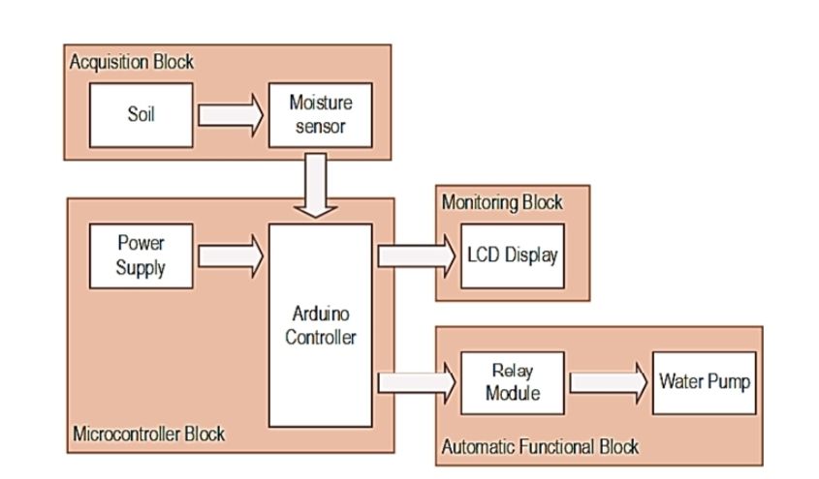

**Requirements:**

1. To Immerse into Soil. We require a Soil Moisture Sensor
2. To perform operate we require a audrino board and Water pump.
3. We can operate it from anywhere.
4. The soil moisture sensor is light up in the controller when it is switched on,

5. Longer Life spam.

**Components:**

**1.Arduino:**

* Arduino is an open-source electronics platform based on easy-to-use hardware and software. Arduino boards are able to read inputs - light on a sensor, a finger on a button, or a Twitter message - and turn it into an output - activating a motor, turning on an LED, publishing something online.

**2.Relay module:**

* Relays are switches that open and close circuits electromechanically or electronically. Relays **control one electrical circuit by opening and closing contacts in another circuit**.
* As relay diagrams show, when a relay contact is normally open (NO), there is an open contact when the relay is not energized.

**3.Water pump:**

* A water pump is a machine used to **increase the pressure of water in order to move it from one point to another.**
* Modern water pumps are used throughout the world to supply water for municipal, industrial, agricultural, and residential uses

**4.Soil Moisture sensor:**

* Soil Moisture Sensors also enable us to develop smart agricultural systems that respond to environmental conditions automatically.
* There are two types of soil moisture sensors:
* One that measures moisture through the electrical properties of the soil: dielectric constant, resistance & ions, and
* the other which measures water potential through the use of gypsum blocks and tensiometers.